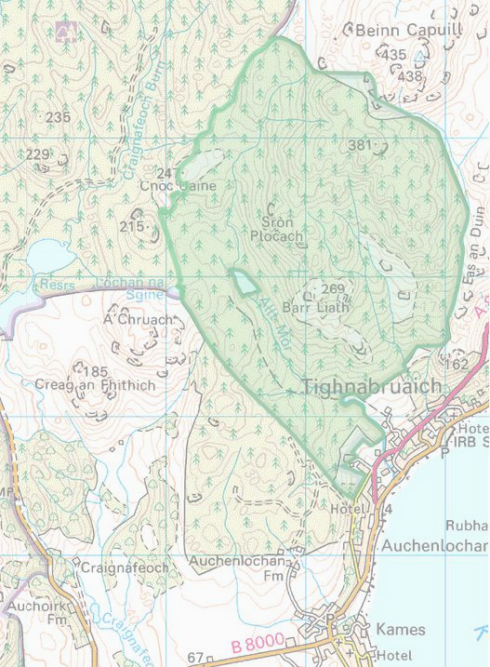

Initial evaluation of the potential renewable energy resources available to the ‘Forest Village’ project at Acharossan by Tighnabruaich

12th December 2005

Report prepared by Robert Borruso

Abstract

The proposed Forest Village development site has a large potential for renewable energy. Indeed the site is almost uniquely blessed with an apparent abundance of renewable energy resources water, wood and wind are all seeming plentiful. The purpose of this study is to ascertain the best ways to exploit these resources for the benefit of the village community and society as a whole while keeping any potentially negative effects of this development to a minimum.

In many ways this project represents a ‘blank canvas’ from an energy supply point of view and therefore the widest possible range of technologies can be considered. The purpose of this study is to separate what is possible from what is practical and establish what technologies warrant further investigation. Special attention is also given to identifying any ‘show stoppers’ or issues that should exclude a particular technology from further investigation.
Contents

1. Hydroelectric potential 5
1. i Reservoir ownership 5
1. ii Regulatory constraints 5
1. iii Available energy resource 6
1.iii.a Theoretical potential 6
1.iii.b Empirical findings 7
1.iv Usage scenarios 7
1.v Reuse of existing infrastructure 8
1.vi Likely equipment costs 8

2. Biomass potential 10
2.i Potential scale of initial resource 10
2.ii Long term biomass options 10
2.iii Conversion technologies - Individual heating 11
2.iv Conversion technologies - Community heating 12
2.iv.a Connection issues 13
2.iv.b Plant issues 13
2.v Conversion technologies – Combined Heat and Power (CHP) 15
2.v.a Table  16
2.vi Revenue generation mechanisms 17
2.vii Anaerobic Digestion (AD) 17

3. Wind potential 19
3.i Large turbines for grid generation 19
3.ii Small turbines for individual needs 19

4. Solar potential 20
4.i Solar thermal 20
4.i Solar PV 20

5. Further Work and Funding options 21
5.i Technologies warranting further investigation 21
5.ii Funding options 22
5.ii.a SCHRI 22
5.ii.b HICEC 23
5.ii.c Other options 23

Photographic Appendix 24

1. Hydroelectric potential

Within the site there is a disused reservoir that presents an obvious opportunity for hydroelectric development. Initial inquires reveal a storage capacity of >40 ML with a potential head of 70m. Although at first glance this appears to be a substantial energy resource. The actual amount of energy that will be available to the forest village will depend on the net flow rate through the reservoir and the level of abstraction allowed by the regulatory authorities (Scottish water and SEPA)

1. i Reservoir ownership

At present the reservoir is owned by the West of Scotland water company. Despite numerous attempts to contact the relevant office no reply has been received as to whether and under what conditions the water company would be prepared to release the reservoir to the Forest Village project. Naturally this is critical in terms of hydroelectric development and attempts at getting a definitive answer are continuing.

1. ii Regulatory constraints

The responsibility for safeguarding surface waters in Scotland falls to the Scottish Environment Protection Agency (SEPA). Any diversion of water from the reservoir or the small river fed by its overflow would therefore need explicit approval of SEPA. Achieving the required permit is critical as without it any hydroelectric development would be illegal. As with any such application the process can be quite involved, with costs as high as £2,000 should SEPA require a full independent environmental impact assessment. Fortunately many of the suppliers of small scale hydroelectric systems have experience of regulatory process and offer a service whereby they will guide the customer through the process, for a small additional fee.

1. iii Available energy resource

Assuming that SEPA do not place severe restrictions on the level of abstraction, estimates as to the potential energy resource that the surface water within the site might represent can be made. By both theoretical calculation and empirical observation.

1.iii.a Theoretical potential
The Alt mor reservoir at the centre of the site was originally used to supply drinking water for Tighnabruaich. Its use for this purpose appears to have ended in 2001. Since then, with no extraction, the reservoir regularly overflows the weir built into the NE end of the dam into a spill way that joins the original Alt mor burn stream bed 50 metres lower down. The reservoir is said to contain at least 40million¹ litres of water. Measurements taken from an ordinance survey map indicate an elevation difference of about 70m between the surface of the reservoir and the lowest practical position for a generator building. In simple potential energy terms this volume of water effectively stores 4.5 MWh of delivered electricity². It has been suggested that the reservoir once supplied around 500 dwellings and assuming an average daily water consumption of 400l per dwelling it would therefore be fair to assume a daily flow through the reservoir of 200,000 litres. This would suggest a theoretical daily output of 22.8 kWh².

Notes :
1. According to verbal statement by a former reservoir manager
2. Power (kW) = Head (metres) x Flow (m3/second) x Gravity (9.81) x Efficiency (0.6).

1.iii.b Empirical findings
A number of visits to the reservoir have been made under a variety of weather conditions. After a period of the average rainfall the overflow at the weir into the burn was found to be a continuous 40 l/s this would equate to a constant electrical output of 16.4 kW or 393kWh per day. The main issue with this level of water abstraction would be the need to maintain a minimum level of flow in the Alt Mor burn. To establish how the flow of the burn is affected by the quantity of water coming over the weir a second site visit was made after a dry period (10 days without rain) in November 2005. While there was almost no water coming over the weir the level of flow in the burn had not dropped to a point where significant parts of the stream bed were exposed or exhibited no water movement (stagnation). Photographs of the burn taken during the site visits showing water flow can be found in the appendix. This would suggest that generally the flow in the burn is maintained by seepage from the reservoir and tributaries joining the burn below the dam.

1.iv Usage scenarios

Though the level and timing of water abstraction will be dictated by the terms of the abstraction licence, considering possible consumption patterns at an early stage remains good practice. The most obvious and straightforward use would be to run a relatively small generator, matched to the maximum allowable abstraction rate more or less constantly. Generating for the forest village and exporting any surplus (and importing any shortfall) as consumption patterns dictate. The exact economics of this regime would be for the most part be determined by any deal struck with an electricity supplier. However, if a biomass CHP (see section 2) were deemed feasible then an alternative usage scenario using a larger turbine would be possible. Whereby the CHP provides base load generation and the hydro system provides peak load support for relatively short periods of time. Though having a larger generator running for fewer hours would at first seem like an inefficient use of what would be an expensive asset, much of the extra cost could be offset by removing the need for a high capacity grid connection. Additionally such a system would fit in more closely with the Forest Village goals of self reliance.

1.v Reuse of existing infrastructure

The existing infrastructure at the site consists of the dam itself and the old water supply pipe down to the bottom of the site. The dam of course represents a liability as well as an asset. The consequences of any failure in the dam structure likely being dire. The terms under which the forest village could utilise the dam would likely require some legal agreement with West of Scotland water co. covering these liabilities. Conversely the old water supply pipe represents much less of a problem as the consequences of any failure are less severe. Its reuse as a supply pipe to feed the hydroelectric generator would be dependant on the consent of the water company and its current condition. It should be remembered however that even a small amount of the survey work and/or repair work to this pipe might well work out more expensive than laying in a new modern (low static pressure loss) plastic pipe down to the proposed generator site. At the time of report completion, no indication from the water company has been received as to the condition of this pipe.

1.vi Likely equipment costs

The cost of installing a hydroelectric system as part of the forest village development can be broken down into two distinct areas, equipment costs and installation costs. With the cost of equipment, generator, electrical controls etc. varying much more with the size of the system than will the installation costs.
The principal equipment cost is the purchase of the turbine, as the available head at the site is relatively high a Pelton wheel turbine is likely to be most suitable³. Usefully Pelton wheels can be ‘tuned’ to some degree to ensure output is maximised despite any variations in flow rate. Equipment supply costs for this type of system turbine + alternator + mechanical controls vary from £1500 per kW in for the lower output (<2kW) devices to £500 per kW for higher output (>15kW) machines.
Installation costs are likely to vary much less with turbine power. For example the cost of building a turbine house would be the same for all sizes turbine being considered. More importantly (in financial terms at least) the cost of laying a new supply pipe from the reservoir to the generator should it be needed, is not significantly effected by the diameter of that pipe. As the cost of the actual pipe itself only makes up a small part of the total cost of the pipe installation.

Notes :
3. http://www.hydrogeneration.co.uk/intro.htm
The turbine type which is suitable for a particular site depends on the head which is available.
Four turbine systems which can be installed at reasonable cost are listed in Table 1 with appropriate head ranges.
Turbine Type | Head Range
Propeller | 1.5 to 5 metres
Cross-flow | 3 to 20 metres
Pump-as-Turbine | 15 to 30 metres
Pelton | 25 metres +

2. Biomass potential

By far the most abundant source of renewable energy within the proposed development site is biomass. Though opportunities potentially exist for the recovery of energy from sewage and garden waste it is wood or more specifically wood waste that represents the most easily exploited of the biomass sources available to the development.

2.i Potential scale of initial resource

During the construction phase of the project very large quantities of principally ‘green’ (high moisture content) wood will be produced in quantities could well run into 100’s of tonnes. This will be at a time when the need for the energy produced from this resource will be undeveloped. Certainly, in the first five years of the development the supply of waste wood will far exceed the potential demand for energy. It should therefore be accepted that during these early stages of the development much of the potential biomass energy resource will remain unexploited. However, it should be remembered that in the wider context of the development this does not constitute ‘waste’ as even left untouched to decompose where it was felled; timber provides a valuable resource aiding woodland regeneration and improving biodiversity.

2.ii Long term biomass options
Of the 452 ha proposed site some 300 ha is conifer plantation. The long term management plan calls for this area to be reduced to around 200 ha of woodland managed for timber, mainly replanted conifer. Preliminary enquiries⁴ suggest a growth class of 8-10 m³ per hectare per year of round wood.
Notes :
4. Verbal estimate from Gordon Gray Stevens AGWA
Assuming a calorific value⁵ of 4 GJ per m³ the timber produced on the site has an energy potential of 4000GJ (or 1111 MWh) per year⁶, enough to heat and light 123 homes⁷. Assuming of course that conversion to energy is the best use for the timber produced from the Forest Village project. The reality is however that most of the timber produced (after the initial poor quality plantation clearance has taken place) will be of a reasonably high quality and therefore conversion to energy would not represent its best use. Even after taking this fact into account there will still be substantial amounts of ‘off-cuts’ and other conversion waste, perhaps as much as 25% of the total crop. This would give a ‘real world’ potential of 1000GJ.

2.iii Conversion technologies - Individual heating

By far the simplest way to exploit this substantial resource is to equip each dwelling with a modern solid fuel central heating system. Such systems are in widespread use across the developed world. Their marginal capital cost of installation (i.e. the additional cost over and above a conventional alternative) when compared with say, electric storage heaters could be as much as £3000 per dwelling. However, in a part of the world where the cheapest domestic heating fuel (mains gas) is not available many choose oil or LPG as heating fuels both on the grounds of lower long term running costs and improved thermal comfort.

Notes :
5. Actual values are difficult to come by as they can be effected by individual site conditions, management regimes etc. the figure of 4GJ m³ has been arrived as after extensive review and therefore the actual figure is unlikely to differ substantially from the above quoted.
6. 4GJ x 10 m³ ha yr x 200 x 50%(conversion efficiency) = 4000GJ
7. Assuming 3 MWh electric consumption and 6 MWh thermal consumption

When viewed in these broader terms the additional capital cost of modern wood fired heating systems is unlikely to be more than £1000⁸. Though at this stage exact figures are difficult to give as the availability of low output systems suitable for very well insulated dwellings of the type envisaged for the Forest Village is limited. One often sited drawback of solid fuel systems is the relatively high levels of user intervention required to keep the system running smoothly, emptying ash etc. A fact that has led to the decline of such systems even in places where alternative fuels are more expensive. However, in the Forest Village context this issue will be less significant as the individuals involved are unlikely to be put off by the additional work involved given the very obvious benefits to them.

2.iv Conversion technologies - Community heating

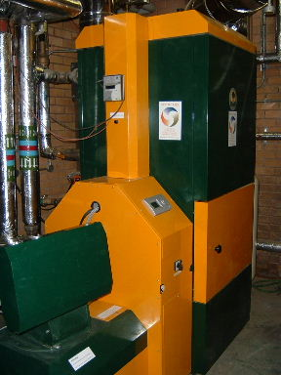
One of the potential disadvantages of using individual systems is that there is little scope for economies of scale. Installation and service costs rise in direct relation to the number of dwellings supplied e.g. the costs for twenty dwellings are about ten times what they would be for two. One often used way round this is to set up a community⁹ heating system whereby a centralised boiler plant delivers heat (as hot water) to the individual dwellings via a system of underground pipes.

Notes :
8. http://www.est.org.uk/schri/downloads/biomass_o_p.pdf
9. Sometimes called a district heating system. The differentiation is one of nomenclature and is of no real technical significance.
Picture: 100 kW Boiler at Oakengates Theatre, Telford. Midlands wood fuel ltd
Such systems servicing sometimes ten of thousands of dwellings are very common in mainland Europe and have been installed in some major developments in the UK.

2.iv.a Connection issues
As with domestic heating systems the cost of community heating installation is highly site specific. Factors such as house positioning, site topography even load profiles can all significantly affect the final cost of laying in the pipe work. Therefore, at this early stage of the project meaningful costings cannot be given. Unfortunately it is this part of a community heating installation that can prove [prohibitively] expensive especially in relatively low density developments, with costs for installing the necessary pipe work potentially as high as £100¹⁰ per meter. Careful and realistic costings have to be made at the detailed design stage of the project to ensure that any economies of scale, potentially afforded by the use of a shared boiler are realized. Indeed many community heating (and CHP) systems have failed due to problems caused by overpriced or poorly specified distribution pipe work.

2.iv.b Plant issues
There are a variety of technologies available for converting wood waste into useful heat. They vary in the level of processing required before the wood is suitable for use as a boiler feed stock and the level of human attention required to ensure reliable running.
The most straightforward systems on the market at present are wood pellet boilers. They are compact, fully automatic, can have variable output and require only a daily hopper filling. The major issue that needs to be addressed with this type of boiler is the supply of pellets,

Notes :
10. Here again exact costings are very difficult to come by. Though cost reductions could be made by some sort of ‘self installation’ work. What effect this would have on any manufacturer guarantees need to be ascertained.
which are usually manufactured from saw mill waste. The machines for manufacturing wood pellets from such waste are large and expensive and given the relatively modest scale of forestry operations likely to be undertaken within the Forest Village, on site pellet production would probably prove uneconomic.
Wood chip boilers are similar in operation to wood pellet boilers, indeed some plant will run on both. Wood chips require less processing to produce than wood pellets and would not require the purchase of any machinery that was not already on site. However, due to the lower calorific value of wood chip large quantities will need to be processed to provide energy for the entire development. This processing both in the actual chipping and the air drying is time consuming and unpleasant work which would more than negate the labour advantages to be had from utilizing an automated boiler.
Log boilers are perhaps the most suitable technology for any forest village community heating system. The boilers are larger and require more regular ‘stoking’ compared to automatic feed pellet and chip boilers. Output too is less controllable though the technology is advancing rapidly in this area. But log boilers do have one major advantage, namely the minimal levels of processing required to turn wood waste into boiler fuel. Simply chopping, stacking (for air drying) and storing the wood for 12 months is all the work required. This does require a lot of ‘shed space’ which might be a problem for a more urban development but represents no problem for the Forest Village development.
Boiler technology is an area where the technology is advancing all the time with new systems appearing regularly. But at this stage further work should be focused on ascertaining the most appropriate log fuelled system for the project.

2.v Conversion technologies – Combined Heat and Power (CHP)

CHP perhaps offers the most exciting biomass to energy opportunities within the Forest Village development. There will be an unavoidable need for electricity within the development and if a conventional energy supply route were followed this would mean an increasing flow of revenue leaving the community to an external electricity provider. In many ways CHP can be thought of as a progression from community heating whereby both heat and electricity are supplied to the community from a centralised community owned plant.
Though there are many different types of CHP systems available as outlined in table they all rely on the combustion of the biomass to generate heat that can then be used to drive a generator as in a conventional power station. The difference is whereas a conventional power station discards this process heat (e.g. using a cooling tower) after it has generated the electricity a CHP system can recover this heat by say feeding it into a community heating system. Taking into account the intrinsic inefficiencies in the national grid the potential energy in the original fuel can be converted into useful energy supplied to consumers at effective thermal efficiencies of over 100%¹¹.
On the face of it such an efficient system would seem to provide a substantial potential scope for revenue generation. Indeed CHP systems can have positive net present value but only if they are sized, installed, operated and maintained according to the findings of a detailed and accurate cost modelling study.

Notes :
11. Assuming a CHP with 35% electric efficiency and 45% thermal totalling 80% gross and assuming a thermal efficiency of 38% for grid supplies. Therefore 100 units of thermal input to a CHP gives 45 units direct thermal output and a further 92 units (35%/38%) thermal energy displacement on the grid. Giving a net potential output plus saving of 137 units or 137%

2.v.a Table 
Characteristics  Technology | Output range  kW_{e} | kW_{t} to kW_{e}  ratio¹ | Δt | Generator energy source | Approx.  £ / kW_{e} | Relative  Service costs | Market  readyness
Steam turbine | 1kW – 100MW | 1.2 | >200°K | Dry steam | £500 - £2000 | Low | Off the shelf
Gas turbine | >100kW | 0.85 | 1500°K | Kerosene,  Natural gas | £1500 | High | Off the shelf
Reciprocating piston (spark ignition) | 5kW – 2MW | 0.7 | 800°K | Natural gas³ | £1000 | Medium | Off the shelf
Reciprocating piston (compression ignition) | 5kW – 2MW | 0.75 | 800°K | [Bio]Diesel, natural gas, Biogas, Producer gas, Pyrolsis oil | £1200 | Medium | Of the shelf for conventional fuels⁴
Stirling engine | 0.8 – 50kW | 0.3 – 0.5 | >300°K | External Combustion gases | N/A | N/A (should be low) | Pre- production
Steam engine | 0.1 – 100kW | 0.1 – 0.3 | <200°K | Steam | N/A | N/A (should be low) | Prototypes in development
Notes
- Where 1 would mean electric output equal to thermal and 0.5 would mean a thermal output twice that of the electric
- Though small steam turbines <50kW_{e} do exist the cost of the high pressure steam plant would be prohibitively high if just installed for the generator. Using low pressure steam would seriously effect efficiency to the point of non-viability
- Biogas or the producer gas (from a wood chip gasifier) could be used but the variability in the calorific value of these fuels would cause far fewer problems for a compression ignition engine.
- CI reciprocating piston engines can be made to run on just about any liquid or gaseous fuel. However, the further removed from diesel this fuel is the more difficult managing the combustion process will be. Additionally the plant for turning biomass into suitable fuel (gasifiers pyrolisers etc.) though widely available have proved problematic in a number of pilot projects.

2.vi Revenue generation mechanisms

Regardless of which CHP technology is used the level of capital investment required both for purchasing the plant and installing a community heating system will be substantial, even if some grant funding is obtained. Additionally such a system will require long term maintenance over and above what a straightforward heating system would require. However, because the system will produce both heat and electricity substantial revenue opportunities exist. The most commonly adopted method for financially managing small scale CHP is to setup what is called an ESCo. (Energy Services Company). A typical ESCo. would be an independent not for profit community owned company which would purchase, own, operate and maintain the plant and distribution pipe work. Local electrical infrastructure could also be provided via a private wire system thus creating a complete Local Energy Network. It would then sell the heat and electricity generated to the members of the community. It is this revenue that would pay the ESCo’s operating costs (including capital repayments). Such an arrangement can ensure the long term viability of the project insulating the community from the vagaries of the commercial energy market whilst providing a long term revenue stream to keep the CHP operating independent of transient grant funding. However, the economics of such arrangements can be very marginal therefore accurate project costings and revenue projections need to be made, as it is rarely technology that causes a project to fail but rather unrealistic expectations of what it can deliver.

2.vii Anaerobic Digestion (AD)

There is another biomass energy technology that is worthy of mention, namely anaerobic digestion. Though in many ways it is more of a waste management / recycling technology than an energy technology.
The principal is simple and is in widespread use all over the world, using low cellulose organic matter e.g. food waste, garden spoilage, sewage solids etc. This feedstock is mixed, macerated and left to decompose under anoxic conditions for a period of time. Natural bacteria present in the feedstock convert the organic materials into a mixture of methane, carbon dioxide and nitrogen (often called biogas) with a calorific value of about half that of natural gas. This gas if cleaned can be used as a cooking fuel but as the cleaning process creates problems of its own, AD produced biogas is more conveniently burned in a rejetted conventional boiler or CHP (see previous section). There are issues to do with the final disposal of the residue from the digester (or digestate) and further investigation of these would be essential if the use of AD were to be explored further.
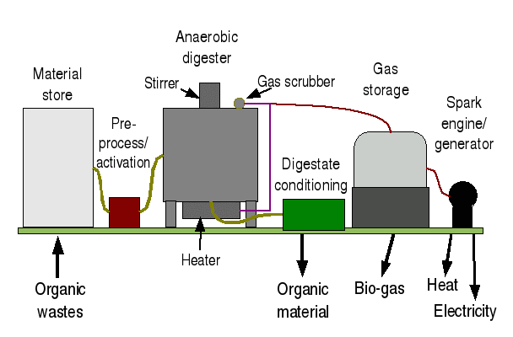
An example of the AD process

3. Wind potential

3.i Large turbines for grid generation
The installation of large grid generating wind turbines are some of the most contentious environmental issues in the west of Scotland at the moment. A full site specific survey would be required to ascertain what the actual potential is. Though there is likely to be a significant resource in the area as suggested by the proposal to build turbines at Ardrossan in Kintyre a short distance away. Unsurprising this scheme met with local opposition which means that any suggestion to build a large turbine as part of the Forest Village development would likely meet with well organized opposition too. Taken in the wider context of the project (abundant biomass and some public skepticism) an application for a large turbine would seem inappropriate.

3.ii Small turbines for individual needs

Though visually much less intrusive small domestic scale turbines might still be seen as the ‘thin end of the wedge’ by those who might be minded to make representations to a planning committee. Though smaller turbines require much less pre-planning application work there is still a risk that costly survey work might be done for no immediate benefit. And considering that the site is blessed with an abundance of renewable energy resources even the installation of a smaller turbine in the early phases of development might well not be the best use of limited capital, both monetary and political.

4. Solar potential

Though the west of Scotland is not known for its sunny climate there is more solar potential available than many would imagine. With the costal strip away from the mountains receiving around 1000kWh m² per year. Usefully unlike wind energy solar developments do not usually meet with public opposition. There are two solar energy options solar thermal and solar electric or photovoltaic (PV).

4.i Solar thermal
Individual panels providing domestic hot water, predominantly in the summer, are by far the most common renewable energy system in the UK. With costs on new build currently no more than £1500 equipping each house with a solar thermal system is certainly a low cost low risk option. The only consideration that needs to be made is how this will integrate with any potential community heating or CHP system that might have substantial ‘spare’ heat available during the summer months.

4.i Solar PV

Despite being just about the highest profile renewable energy technology PV still have their problems. Principle among which is the very high cost still at around¹² 32p per kWh. Therefore unless significant grant funding can be acquired PV’s would not represent an economic use of development capital.

Notes :
12. Installed costs without grant funding are around £6000/ kW_{p} . With a 1 kW_{p} giving on average 750 kWh output per year and lasting at best 25 years that’s 32p per kWh.

5. Further Work and Funding options

The aim of this report is to establish what technologies are available and relevant for the forest village development. Further work will need to be carried out including detailed site surveys and cost modeling to ensure that the most appropriate technologies are employed.

5.i Technologies warranting further investigation
Hydro electricity, perhaps the most promising resource available to the development. Once ownership issues around the reservoir have been resolved a formal approach to SEPA can be made. It is their response that will largely dictate what type of hydro development will take place.
Biomass is the largest resource available to the development but the cost of conversion to useful energy is high. Costs and practicalities of installing community heating need to be established including what level of ‘self-install’ would be viable. Formal approaches to manufacturers of Stirling and steam engine CHP need to be made as these seem to be the most suitable technologies for a development of this type. Though, after establishing a cost model for a CHP operating ESCo. this might change. Based on these findings a decision can be made as to which energy from biomass technology should be employed. Issues surrounding disposal of the AD digestate need to be resolved also agreement in principal from SEPA for using AD as a sewage treatment system would need to be sought.
Solar Thermal - establish suitability after load profiles from any potential CHP have become clear.

5.ii Funding options
It is an unfortunate reality that funding for renewable energy systems is influenced as much by political expediency as the need to build up a financially viable renewables sector¹³. Therefore information given in this section is liable to change between the time of writing and when the project starts on site, making detailed research at this stage of limited value. That said at present there are two obvious funding streams Scottish Community and Householder Renewables Initiative (SCHRI) and The Highlands and Islands Community Energy Company’s (HICEC) Revolving Investment Fund.

5.ii.a SCHRI
Will provide up to 100% funding at both feasibility and installation stages of a project, though a level of around 50% seems more common. The conditions to securing funding are that the proposing body meets their criteria¹⁴ and only approved products and installers are used. It is the latter point that might well prove problematic if for example a new (to this country) wood fuelled CHP system emerged as the preferred system. It should also be noted that SCHRI is in many ways the Scottish equivalent of Clear Skies in England which has recently been ended early though current there is no suggestion of the same happening in Scotland¹⁵.

Notes :
13. As the experience of the early demise of the clear skies and the MPVDP has shown in England. Relying on the government funding as part of a long term renewables financing package could be seen as folly.
14. More details can be found at http://portal.est.org.uk/housingbuildings/funding/scotland/getting/
15. The SCHRI is set to run until March 2008

5.ii.b HICEC
Has setup £700,000 rolling investment fund whereby money is provided for community energy projects in the form of what is basically a loan albeit a loan with generous conditions. Repayment of capital is expected basically limiting the funding to projects that can show positive net present value. There is no constraint on the type of technology used except that it delivers carbon savings and has some degree of economic viability. A separate fund the “Technical Assistance Fund” is also available for high risk e.g. pre-planning approval work which can be in the form of grant or loan. This might well be suited to the work required in getting SEPA approval for abstraction from the reservoir.

5.ii.c Other options
There are numerous other bodies governmental, commercial and philanthropic that might be interested in funding aspects for the Forest Village development. Approaches to these organisations should be made as part of a more detailed feasibility study. However, availability of funding should not be allowed to unduly influence the choice of technologies employed at the Forest Village.

Photographic Appendix
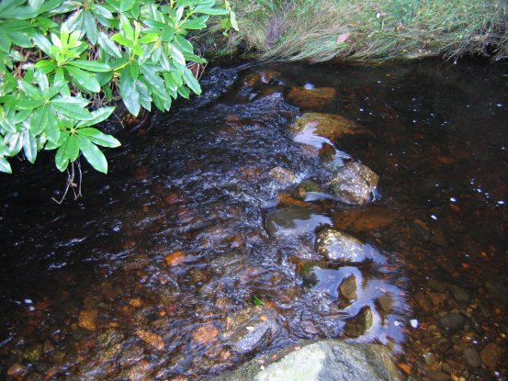
27/10/05 After rain
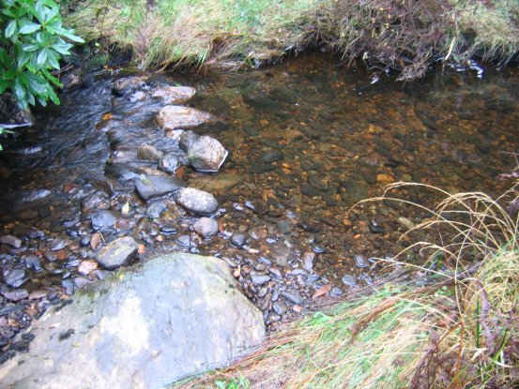
23/11/05 After 10 days without rain
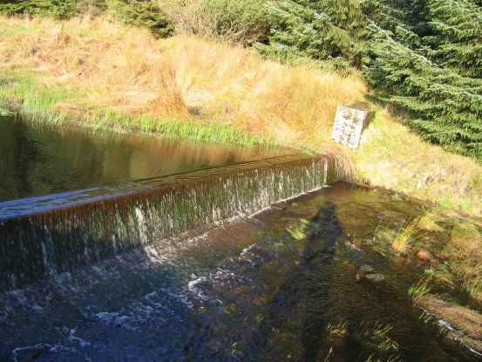
27/10/05 After rain

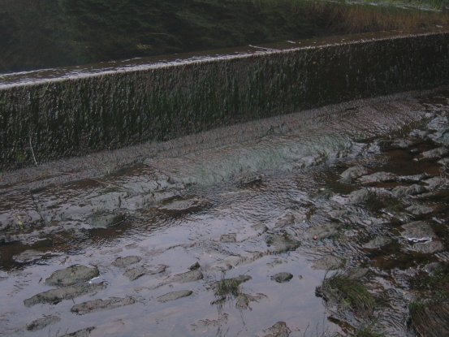
23/11/05 After 10 days without rain

